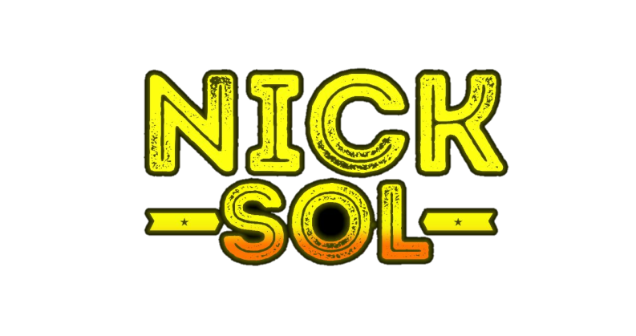
Vídeo Clipes, Matérias Especiais, shows.

Materias:

Entrevista Kondzilla / Preto Zezé / https://www.youtube.com/watch?v=u0MJ1AQFS34

Programa do RV : https://www.youtube.com/watch?v=y6K2IReM4r4&t=198s
Parte II: https://www.youtube.com/watch?v=lUPphRaikBM

Se Liga (Verdes Mares): https://www.youtube.com/watch?v=gagAM453RZs&t=381s
Programa Tarde Livre: https://www.youtube.com/watch?v=UIC8VKThHRM&t=322s
Programa Zonna Vip: https://www.youtube.com/watch?v=dXOMwPMooWQ
Programa Tudo Por Elas, TV Diario: https://www.youtube.com/watch?v=XIZqOqLwvJc
Programa Levanta Poeira, TV Diario: https://www.youtube.com/watch?v=VdtM7mrWCpI
Programa Arena Hit, TV Diario: https://www.youtube.com/watch?v=sWFSh9xKhmg&t=38s
Programa Ênio Carlos: https://www.youtube.com/watch?v=xKpo_9qT-5o&t=276s

Clipes

Ela Tem Moral Na Quebrada
https://www.youtube.com/watch?v=cGjcQ-VfUjg

Novinha Do Paredão
https://www.youtube.com/watch?v=cGjcQ-VfUjg

Carnaval Chegou:
https://www.youtube.com/watch?v=sK0abiLOdSs

Quero Vê A Tua Marra
https://www.youtube.com/watch?v=IGqfUJhvf3s

Vai Brasil
https://www.youtube.com/watch?v=HdZpHL7aVuE

Dona Do Baile
https://www.youtube.com/watch?v=2_T1_cNy1GA

Hipnotizar Você
https://www.youtube.com/watch?v=RJlX5YsrCR0

Revoltada
https://www.youtube.com/watch?v=yxEzrGhjMxk

No Talentinho
https://www.youtube.com/watch?v=zgsq9yHmIsw

Ela É A Sensação Do Momento
https://www.youtube.com/watch?v=P_7CcdJRwoc

Kika Empina
https://www.youtube.com/watch?v=AzQ4wxk85SE

Na Batida
https://www.youtube.com/watch?v=yuh0H3DYeMM

Shows:
Parada da Diversidade de Maracanaú: https://www.youtube.com/watch?v=Ez48OKq6Og4
Aftermovie Samba Brasil: https://www.youtube.com/watch?v=qTEqK5eYRHY
Carnaval de Camocim 2019: https://www.youtube.com/watch?v=kLzbVu8vy_w
Part. Com a Banda Forró Real na cidade de Camocim: https://www.youtube.com/watch?v=hIKnCqjXd1Y
Carnaval 2020 – Mercado Dos Pinhões: https://www.youtube.com/watch?v=uj82QRmyQuo
https://www.youtube.com/watch?v=fdMj3ZRceRg
https://www.youtube.com/watch?v=7022BXlQObk
Largos dos Tremembes: https://www.youtube.com/watch?v=ynPByLh9evY&has_verified=1
Carnaval de palmacia 2020: https://www.youtube.com/watch?v=5mmGR7uAJgs

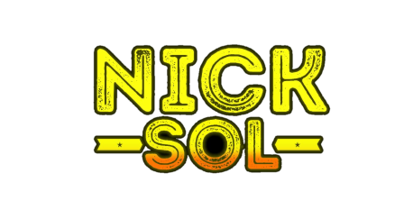

Lives.
Live Solidária: https://www.youtube.com/watch?v=tQR71Xoq3tM&t=7726s
Live Talentos Da Perifa: https://www.youtube.com/watch?v=FM6rl07OacU&t=3714s
Live Melhores do Ano, Talentos da Perifa: https://www.youtube.com/watch?v=c9rG-JHhaOw

Pocket DVD - PROJETO FUNK SEM PRECONCEITO
CRIA DA FAVELA (NA LAJE)
https://www.youtube.com/watch?v=pGFJ9jEasfI&feature=youtu.be

